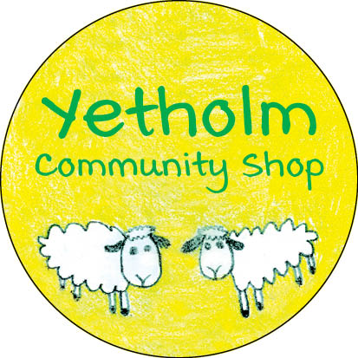
VOLUNTEERS

An important part of our buy-out plan has been to reduce overheads in the shop by using volunteers alongside the paid staff.
We have already been lucky enough to have several individuals who have been volunteering their services in back-office capacities, and we are very grateful to them.
Our original surveys back in 2019 identified a number of community members who expressed an interest in playing an active role in helping with the shop to operations, and we recently followed up with them, primarily in relation to till counter staffing since our electronic point-of-sale equipment is now up and running. Responses were encouraging.
Given the time which has passed since 2019, we are also aware that there may well be others in the community who are not on our database as potential volunteers, but who would like to volunteer some of their time and energy in support of the shop project. There is certainly room for others to come forward now – and not just as counter staff. We do want to build a robust roster of volunteers to call upon.
Plainly, there will be lots of operational detail to be considered, such as training, days and hours, etc., but these can be worked out in the light of individual preferences.
Any one of us below would be very happy to hear from you as soon as convenient.

YCSL Management Committee
Alastair Hirst (alastair.hirst@yahoo.com 420 214)
Kay Greenhorn (kaygreenhorn@hotmail.com 420 560)
Susan Stewart (j.stewart134@btinternet.com 420 231)
Graeme Wallace (graemwme@icloud.com 420 677)
Neil McIntyre (ngmcintyre@hotmail.com 420 560)

