UPDATE SEPTEMBER 2020 – Good News!!!!

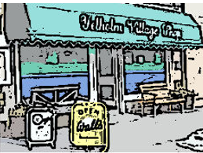

As many of you may have already heard today, our application for Stage 2 funding from the Scottish Land Fund has been successful. We have been awarded a grant of £114,000. We are delighted with the decision of the Scottish Land Fund to support the community buy-out project for our village shop. This is the first, and most important, step in our fund-raising effort, and it will open the way to securing the further funding we need in order to acquire, repair, re-fit and recapitalise the shop enterprise and maintain it in being for future years as a vital centre of village life.

The next key step towards the acquisition of the shop is to proceed with the Public Offering of shares in the Community Benefit Society, and an announcement will be made very soon regarding the timing and all other important details of this process.

