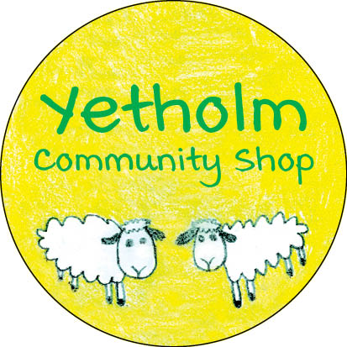

FUNDRAISING UPDATE – NOVEMBER 18, 2020

ONLY 4 MORE DAYS TO GO!

Just four more days to the end of the share offer subscription period, and we are approaching the finish line! The community response has been very strong, and as we come to the final few days of the campaign, we are pleased to report that as of Tuesday, November 17th, we have received share subscription forms and donations to a value of £102,815.

This has been so far a tremendous effort from our community and has firmly demonstrated how much we recognise the value of our shop. A huge ‘Thank You’ goes out to all those who have subscribed for shares or made donations thus far. However, there are still quite a few pledgors that we have yet to hear from. As these pledges represent a significant amount of money, we need to ask once more for those remaining forms to be returned and to make one last push to see us over the line and Save Our Shop!

(Additional subscription/donation forms can be obtained from the shop, any member of the management committee, or downloaded from www.yetholmonline.org/yetholm-village-shop )

