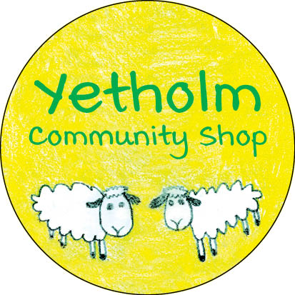

SHOP NEWS – AUGUST 29, 2021

Here is an update of the main developments since our last bulletin.
Supplier issues – One of our key suppliers continues to face challenges in meeting their delivery commitments, due to supply chain issues including a lack of delivery drivers, which has necessitated our using other sources to restock the shop. Sometimes this has meant that we have been unable to obtain a number of our regular items. We have done our best to minimise the impact from this, and we have been told that this disruption should be easing in the near future.
Post Office – We are still waiting to hear further from the Post Office regarding the timing of the audit and training and other formalities which will allow a date to be fixed for the formal transfer to YCSL. Unfortunately, there is little that we can do to move this forward and will provide a further update as soon as we can. In the meantime, the lack of Post Office -accredited staff has meant that we’ve had to close the PO counter on Wednesdays due to staff holidays, but we’re hoping to get back to 6-day working soon.
Staffing: Employees & Volunteers – We have now built up a roster of 14 volunteers who are making a valuable contribution serving behind the counter. We thank our customers for their patience as our new recruits learn the ropes, including the intricacies of our EPOS system and the alcohol retailing regulations. We would like to thank them and all of our other volunteers, including those who are working behind the scenes, for their time, while also reminding everyone again that we always have a need for more. If we can enlarge our volunteer panel, this will help us to extend our opening hours.
Refurbishment plans and temporary relocation – We have been working with an architectural technician, and others, to refine our plans for the refurbishment and refit prior to submitting our planning application. A particular issue we have been giving much thought to is the improvement of the pavement area directly in front of the shop. We now anticipate that the work will take place early in 2022, with a temporary relocation of the shop during the work period. In the meantime, we have made some minor upgrades to the existing lighting to improve the appearance of the shop interior.
Annual General Meeting - We will need to hold our first AGM for shareholders in the next few months, and we will be announcing the arrangements for this in due course.

SUPPORT YOUR SHOP – SUPPORT YOUR COMMUNITY!

