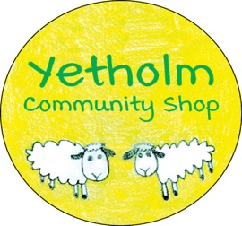
KEY DEVELOPMENTS TO DATE – APRIL 30th 2021
We are pleased to bring you this first news bulletin for Yetholm Community Shop since our benefit society became the owners of the business, and there is a lot of activity to report.
First, thank you again to all those who have supported YCSL financially, and of course to our loyal customers. As we have said before, a major element in the future sustainability of the shop is the need to increase turnover so we are delighted to see old faces and look forward to welcoming new ones. We want also to thank our staff for helping us through this transition.
We will be looking to introduce new product lines and special offers, although we will be somewhat constrained in our ability to do this until the refurbishment is complete. Please bear with us as we work to make the shop the best it can be for all of us. Immediate work on the more urgent repairs will start next week
We were able to fully spend our grant from the Scottish Government’s ‘Scotland Loves Local’ scheme. This included a new tablet and printer, the hand sanitiser stand, the replacement chiller, and some of the EPOS equipment, as well as the branded tabards.
We have made some good progress with transitioning to our EPOS system, albeit with some unfortunate delays with the delivery of hardware, and this will enable us to manage our business more efficiently. We thank you for your patience as we move from an analogue to digital environment.
Our formal application for the transfer of the Post Office branch was submitted last month and we are now at the stage of engaging with the Post Office finance team. This is just one of the numerous behind the scenes tasks being handled by the management committee to switch over relationships with suppliers and utility providers to YCSL. You will have noticed that the large deli counter chiller finally expired. While our new floorplan contemplates removing this anyway, in the meantime we have secured a temporary replacement. Many thanks to the Morebattle Shop for not only helping us out with this, but also for the advice, support and staff training so readily offered by Roddy and Pauline. All of this is so greatly appreciated by us.

SUPPORT YOUR SHOP – SUPPORT YOUR COMMUNITY!

