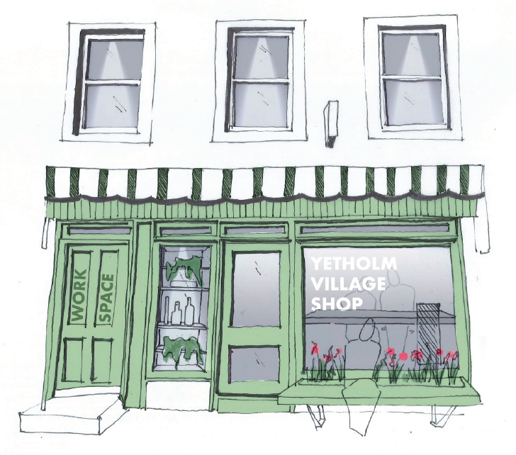
UPDATE BULLETIN – JULY 25, 2020

Submitting our Stage 2 application to the Scottish Land Fund, with all its supporting documentation, was a major effort. We've had informal compliments from the SLF on the quality of our application, but also a caution that there is significant competition for this round of funding. We've also had a very encouraging response to our request for expressions of interest in our community benefit society, Yetholm Community Shop Limited (YCSL), by donating or by investing when the time comes in the proposed share offer. All this is excellent progress.
However, work on the project needs to continue throughout the summer as we wait for the SLF decision by the end of August. Assuming that we'll be successful in securing sufficient funding from grants and from our share offer, we now need to work on our preparations for what may turn out to be a hectic final quarter of 2020. The absolute final date for using any SLF grant is in March 2021, so we can't afford much slippage in our timing of the share offer, the transfer of all the elements of the business and the urgent repairs to the premises.
A vital part of these preparations is to identify the prospective leadership team for YCSL, the "Management Committee" as it is referred to in the YCSL Rules. While we expect that some, if not all, of the steering group members who have worked on the project thus far will be ready to serve on the first management committee, if needed, a much wider range of backgrounds and skills will be required, as well as fresh ideas and energy.

In that regard, we are pleased that Janice Gillies has agreed to join the committee. Janice’s experience and knowledge of the shop’s operations and customer base will provide an invaluable perspective and she will be a welcome addition to the committee. Also, we would like to have members with skill-sets or experience in fields such as retail marketing, property repair and maintenance, IT, public relations and grant funding – or people with governance or leadership experience generally. In particular, we have a specific need for someone with an accounting /financial management background. A community empowerment exercise, such as our shop buy-out project, needs not only financial support from the community, but also a willingness by the community to volunteer personal skills and time.
The YCSL Rules envisage up to 10 management committee members. Under the Rules the first management committee is appointed by the YCSL founders (who are all Steering Group members), but, going forward, as from the first general meeting, everyone serving on the Management Committee will be elected by the shareholders.
In the future, we will also be looking for volunteers to help in the shop and to assist in local fund raising, but, in the meantime if you would like to be part of the Management Committee or can provide advice in the areas listed above, please get in touch with us.

Alastair Hirst | 01573 420214 | alastair.hirst@yahoo.com
Kay Greenhorn | 01573 420560 | kaygreenhorn@hotmail.com
Susan Stewart | 01573 420231 | j.stewart134@btinternet.com
Neil McIntyre | 01573 420560 | ngmcintyre@icloud.com
Graeme Wallace | 01573 420677 | graemwme@icloud.com

